Draw a picture of when you did something EXPECTED!

Draw a picture of when you did something UNEXPECTED.
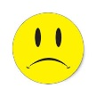

REMEMER: *When you do the expected…you feel good about yourself and others feel good about you too! It makes playing and working together much more fun! *

